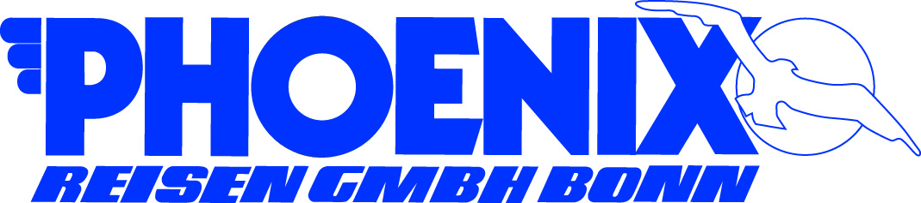**PORT QUESTIONNAIRE**

|  |  |  |  |
| --- | --- | --- | --- |
| Port: | NEW YORK CITY | Arrival Time: | 10:00 on April 21, 2018 |
| Ship: | ARTANIA | Departure Time: | 18:00 on April 22, 2018 |
| Date: | April 21 & 22, 2018 Sat/Sun | Public Holiday: | NO |
| **Name & Address of Port** | | **Name/No. of expected Berth** | |
| MANHATTAN CRUISE SHIP TERMINAL | | TENDERED IN: | |
| 711 12th Ave  New York, NY 10019 | | TBA | |

|  |  |  |  |  |  |  |
| --- | --- | --- | --- | --- | --- | --- |
| PORT FACILITIES | N | Bank | N | Post | Y | Tourist Info |
| *(Please mark with Y or N)* | Y | Telephone | N | Internet | Y | Taxi (on street) |

|  |  |  |
| --- | --- | --- |
| Telephone Country Code and City Code | Dial out code to Germany: | Postage fee to Germany  (postcard / letter) |
| 1-212 | 011 49 | USD $ 1.15 |
| Local Time (GMT +/- hrs) | Languages | Crime Rate |
| + 6 hours | ENGLISH | Average |
| Temperature in Celsius | Humidity | Recommended Clothing |
| Average: high 17 / low 8 | ca. 50% | Comfortable w/ jacket |

|  |  |  |  |  |  |  |  |
| --- | --- | --- | --- | --- | --- | --- | --- |
| Nearest Bank/  Exchange Office: | Banking Hrs. | | Currency | | € 1,- = | US$ 1 = | |
| Chase Bank, 839 9th Avenue | 8:00 – 18:00 | | USD | | $ 1.18 (2017) |  | |
| Accepted Payments | Y | Only local currency | |  | Cash in US$ |  |  |
| *(Please mark with Y or N)* | Y | Credit Cards (please specify): Master Card, Visa Card, American Express, some Diners Club. | | | | | |
|  | N | Maestro/Debit Card | | | | | |

|  |  |  |  |  |
| --- | --- | --- | --- | --- |
|  | City Center | Beach | Airport | Grand Central |
| Name of: | Manhattan | Coney Island | JFK | 87 E 42nd St |
| Distance in km to: | 2.5 km | 32 kms | 31.5 km | 2.7 kms |
| Taxi fare to: | $ 15 | $55 | $53 | $15 |

|  |  |  |
| --- | --- | --- |
|  | Where: | Business/Opening Hours: |
| Tourist Information | At terminal or Grand Central | 9:00 – 18:00 |
| Post Office | 322 W 52nd St  New York, NY New York, NY 10019 | 7:30 – 18:00 (Mon – Fri) |
| Internet Café | Most restaurant, cafes, and fast food places offer free wifi Starbucks almost every corner |  |
| Shopping | Few blocks away | 10:00 to 20:00 |
| Museums | MOMA, MET, Guggenheim | 10:00 to 17:00 |
| Restaurants | Great variety of choices within the City |  |
| Places of interest: | Museums, Intrepid, South Street Seaport, Battery Park, Central Park, Times Square |  |

|  |  |  |  |  |  |  |
| --- | --- | --- | --- | --- | --- | --- |
| Shore leave for pax… *(Please mark with Y or N)* | Y | …with Landing Card | Y | with Passport  recommended | N | …no formalities |

|  |  |
| --- | --- |
| Typical Souvenirs: | License plates, mugs, bags, key chain, cap, “I love NY” T-shirts |
| Special Remarks: | Manhattan’s midtown area on the west side is close the terminal. It’s too short a time to see the entire city so it’s best to do the city tours that covers Manhattans Uptown, Midtown & Downtown areas. Night view of the city is very different and cannot be missed. |